CHAPTER FOUR
DATA PRESENTATION AND ANALYSIS
  - Preamble
In this chapter, we delve into the heart of the research by carefully analyzing the collected data and presenting the findings in a clear and coherent manner. The goal of this chapter is to transform raw data into meaningful insights that address the research questions and objectives outlined earlier in the study. The presentation of results was derived from responses received from the respondents. Descriptive statistics such as percentages, frequencies, mean and standard deviation were used to summarize the demographic data and responses of the questionnaire. Regression analysis was employed to test the hypotheses while putting the null hypotheses to test.

  - Descriptive analysis of the socio-demographic data of the respondents
The socio-demographic characteristics of respondents are crucial for understanding the content of the research and to also provide insights into the diversity and representativeness of the sample.
S/N | Variables |  | (N) | (%)
 | Age | 18–25 | 60 | 42.3%
 | Age | 26–35 | 46 | 32.4%
 | Age | 36–45 | 29 | 20.4%
 | Age | 48 and above | 7 | 4.9%
 | Age | Total | 142 | 100%
 | Gender | Male | 79 | 55.6%
 | Gender | Female | 63 | 44.4%
 | Gender | Total | 142 | 100%
 | Occupation: | Student | 45 | 31.7%
 | Occupation: | Business Owner/Entrepreneur | 28 | 19.7%
 | Occupation: | Corporate Employee | 44 | 31%
 | Occupation: | Self-employed Professional | 12 | 8.5%
 | Occupation: | Other | 13 | 9.2%
 | Occupation: | Total | 142 | 100%
 | Educational Qualification: | SSCE | 29 | 20.4%
 | Educational Qualification: | Diploma | 20 | 14.1%
 | Educational Qualification: | Bachelor’s Degree | 70 | 49.3%
 | Educational Qualification: | Master’s Degree | 11 | 7.7%
 | Educational Qualification: | PhD | 2 | 1.4%
 | Educational Qualification: | Others | 10 | 7%
 | Educational Qualification: | Total | 142 | 100%
 | Have you experienced MTN’s 5G connectivity? | Yes | 104 | 73.2%
 | Have you experienced MTN’s 5G connectivity? | No | 38 | 26.8%
 | Have you experienced MTN’s 5G connectivity? | Total | 142 | 100%
 | How aware are you of MTN Nigeria’s 5G rollout? | Very aware | 88 | 62%
 | How aware are you of MTN Nigeria’s 5G rollout? | Somewhat aware | 42 | 29.6%
 | How aware are you of MTN Nigeria’s 5G rollout? | Not aware | 12 | 8.5%
 | How aware are you of MTN Nigeria’s 5G rollout? | Total | 142 | 100%
 | Have you adopted or considered adopting MTN’s 5G services? | Yes, I have adopted | 68 | 47.9%
 | Have you adopted or considered adopting MTN’s 5G services? | Yes, I am considering adoption | 52 | 36.6%
 | Have you adopted or considered adopting MTN’s 5G services? | No, I have not considered adoption | 22 | 15.5%
 | Have you adopted or considered adopting MTN’s 5G services? | Total | 142 | 100%
 | What influenced your decision to adopt or not adopt MTN’s 5G services? | Cost of subscription | 26 | 18.3%
 |  | Device compatibility | 51 | 35.9%
 |  | Availability of coverage | 31 | 21.8%
 |  | Lack of information | 13 | 9.2%
 |  | Other | 21 | 14.8%
 |  | Total | 142 | 100%

INTERPRETATION
The socio demographic details of the respondents displayed above shows the percentages and frequencies of various categories associated with the respondents. Regarding the age, the highest group of respondents falls within the 18 – 25 age range, comprising 46 participants which accounts for 42.3% of the total. The next significant group is 26 - 35, with 46 respondents accounting for 32.4% of the total, and finally 48 years and above with 7 respondents (4.9%) as depicted above.

The gender distribution shows a significant advantage towards the Male gender with 79 respondents as it accounts for 55.6% of the population compared to 63 female respondents which represents 44.4% of the population.’

In terms of occupation, the majority of respondents are students with 45 respondents accounting for 31.7% of the total. The next is corporate employee with 44 respondents which accounts for 31% of the population, followed by business owner with 28 respondents which accounts for 19.7% of the total, followed by self-employed accounting for 8.5% of the population. It should be noted that 13 respondents chose not to state their occupation accounting for 9.2% of the population.
In terms of educational qualification, those with bachelor’s degree accounts for the highest with 70 respondents (49.3%), followed by SSCE with 29 respondents (20.4%), Diploma comes next with 20 respondents (14.1%), followed by Master’s degree with 11 respondents (7.7%,) and finally PhD with 2 respondents (1.4%) while those that chose not to state their educational qualification account for 7% of the total with 10 respondents.

In the question “have you experienced MTN’s 5G connectivity” a significant number of the respondents agreed with 104 respondents (73.2) while 38 respondents disagreed (26.8).

In the question “how aware are you of MTN Nigeria 5G rollout” 88% of the respondents agree that they are very aware, 42% chose to be somewhat aware, while 12% indicated that they are not aware.

In the question “have you adopted or considered adopting MTN’s 5G services” a significant number of the respondents agreed to have adopted it with 68 respondents (47.9), 52 respondents indicated that they are still considering adoption while 22 respondents indicated that they have not considered adoption.

In the question “what influenced your decision to adopt or not adopt MTN’s 5G services” 51 respondents indicated device compatibility as a constraint, followed y the availability of coverage with 31 respondents, cost of subscription comes next with 26 respondents, and lastly lack of information wit 13 respondents. It should be noted that 21 respondents chose not to state their constraint.
The detailed breakdown of the respondents’ demographic characteristics provides a comprehensive understanding of the diversity within the sample population and also ensures that the findings reflect a broad spectrum of perspectives.

  - Descriptive Analysis of Respondents to Research Instrument

Research Question 1: Perceptions of MTN’s 5G Rollout Strategy
S/N | ITEMS | SA | A | N | D | SD | Mean | S. D
1 | MTN Nigeria’s 5G rollout strategy is effectively communicated to customers. | 31  (21.8) | 50  (35.2) | 41  (28.9) | 8  (5.6) | 12  (8.5) | 3.56 | 1.15
2 | MTN provides adequate technical support for 5G adoption. | 31  (21.8) | 49  (34.5) | 45  (31.7) | 4  (2.8) | 13  (9.2) | 3.57 | 1.14
3 | MTN’s 5G pricing strategy is affordable for businesses. | 25  (17.6) | 40  (28.2) | 46  (32.4) | 21  (14.8) | 10  (7) | 3.35 | 1.14
4 | The network coverage of MTN’s 5G is reliable in my location. | 30  (21.1) | 48  (33.8) | 43  (30.3) | 9  (6.3) | 12  (8.5) | 3.53 | 1.15
5 | MTN’s 5G rollout strategy positions Nigeria as a leader in telecom innovation. | 31  (21.8) | 47  (33.1) | 46  (32.4) | 8  (5.6) | 10  (7) | 3.57 | 1.11

Interpretation of table data:
For question 1: “MTN Nigeria’s 5G rollout strategy is effectively communicated to customers”. 21.8% of the respondents strongly agree, 35.2% agree, 28.9% are neutral, 5.6% disagree while 8.5% strongly disagreed. For research question 2, “MTN provides adequate technical support for 5G adoption.”. 21.8% of the respondents strongly agreed, 34.5% agree, 31.7% are neutral 2.8% disagree while 9.2% strongly disagreed. For research question 3: “MTN’s 5G pricing strategy is affordable for businesses.”. 17.6% strongly agree, 28.2% agreed, 32.4% are neutral 14.8% disagreed while 7% strongly disagreed. For research question 4, “The network coverage of MTN’s 5G is reliable in my location.”, 21.1% of the respondents strongly agree, 33.8% agree, 30.3% are neutral 6.3% disagree while 8.5% strongly disagreed. For research question 5, “MTN’s 5G rollout strategy positions Nigeria as a leader in telecom innovation.”, 21.8% of the respondents strongly agree, 33.1% agree, 32.4% are neutral 5.6% disagree while 7% strongly disagreed.

Research Question 2: 5G and Business Innovation
S/N | ITEMS | SA | A | N | D | SD | Mean | S. D
1 | MTN’s 5G services have improved my business operations. | 24  (16.9) | 48  (33.8) | 44  (33.1) | 8  (5.6) | 14  (9.9) | 3.42 | 1.14
2 | 5G connectivity has enhanced my ability to adopt digital tools (AI, IoT, cloud computing). | 25  (17.6) | 48  (33.8) | 47  (33.1) | 11  (7.7) | 11  (7.7) | 3.46 | 1.11
3 | MTN’s 5G has increased my business efficiency and productivity. | 31  (21.8) | 40  (28.2) | 49  (34.5) | 11  (7.7) | 11  (7.7) | 3.49 | 1.15
4 | 5G has significantly stimulated business innovation in Nigeria. | 20  (14.1) | 47  (33.1) | 52  (36.6) | 12  (8.5) | 11  (7.7) | 3.37 | 1.08
5 | MTN’s 5G services have improved customer engagement in my business. | 28  (19.7) | 45  (31.7) | 50  (35.2) | 9  (6.3) | 10  (7) | 3.51 | 1.10

Interpretation of table data:
For question 1: “MTN’s 5G services have improved my business operations.”. 16.9% of the respondents strongly agree, 33.8% agree, 33.1% are neutral, 5.6% disagree while 9.9% strongly disagreed. For research question 2, “5G connectivity has enhanced my ability to adopt digital tools (AI, IoT, cloud computing).”. 17.6% of the respondents strongly agreed, 33.8% agree, 33.1% are neutral 7.7% disagree while 7.7% strongly disagreed. For research question 3: “MTN’s 5G has increased my business efficiency and productivity.”. 21.8% strongly agree, 28.2% agreed, 34.5% are neutral 7.7% disagreed while 7.7% strongly disagreed. For research question 4, “5G has significantly stimulated business innovation in Nigeria.”, 14.1% of the respondents strongly agree, 33.1% agree, 36.6% are neutral 8.5% disagree while 7.7% strongly disagreed. For research question 5, “MTN’s 5G services have improved customer engagement in my business.”, 19.7% of the respondents strongly agree, 31.7% agree, 35.2% are neutral 6.3% disagree while 7% strongly disagreed.

Research Question 3: 5G and growth of products, services, and processes in Nigerian businesses.
S/N | ITEMS | SA | A | N | D | SD | Mean | S. D
1 | 5G has improved the speed of product development of SMEs in Nigeria business environment | 29  (20.4) | 45  (31.7) | 10  (7) | 49  (34.5) | 9  (6.3) | 3.53 | 1.09
2 | 5G network has improved the quality of technology-driven products in Nigeria | 19  (13.4) | 51  (35.9) | 36  (25.4) | 18  (12.7) | 18  (12.7) | 3.25 | 1.22
3 | 5G network has seamlessly impacted products and service delivery of SMEs in Nigeria | 28  (19.7) | 38  (26.8) | 15  (10.6) | 50  (35.2) | 11  (7.7) | 3.49 | 1.15
4 | There is easy access to 5G infrastructure for all businesses in Nigeria | 20  (14.1) | 16  (11.3) | 40  (28.2) | 54  (38) | 12  (8.5) | 3.38 | 1.12
5 | 5G has improved healthcare service delivery in Nigeria | 23  (16.2) | 42  (29.6) | 15  (10.6) | 46  (32.4) | 16  (11.3) | 3.38 | 1.19

Interpretation of table data:
For question 1: “5G has improved the speed of product development of SMEs in Nigeria environment.”. 20.4% of the respondents strongly agree, 31.7% agree, 7% are neutral, 34.5% disagree while 6.3% strongly disagreed. For research question 2, “5G network has improved the quality of technology-driven products in Nigeria.”. 13.4% of the respondents strongly agreed, 35.9% agree, 25.4% are neutral 12.7% disagree while 12.7% strongly disagreed. For research question 3: “5G network has seamlessly impacted products and service delivery of SMEs in Nigeria.”. 19.7% strongly agree, 26.8% agreed, 10.6% are neutral 35.2% disagreed while 7.7% strongly disagreed. For research question 4, “there is easy access to 5G infrastructure for all businesses in Nigeria.”, 14.1% of the respondents strongly agree, 11.3% agree, 28.2% are neutral 38% disagree while 8.5% strongly disagreed. For research question 5, “5G has improved healthcare service delivery in Nigeria”, 16.2% of the respondents strongly agree, 29.6% agree, 10.6% are neutral 32.4% disagree while 11.3% strongly disagreed.

  - Test of Hypotheses (Inferential Statistics)
    - Hypothesis One
H_{o}: The implementation of 5G networks have a significant impact on business innovation in Nigeria.
H_{i}: The implementation of 5G networks does not have a significant impact on business innovation in Nigeria.

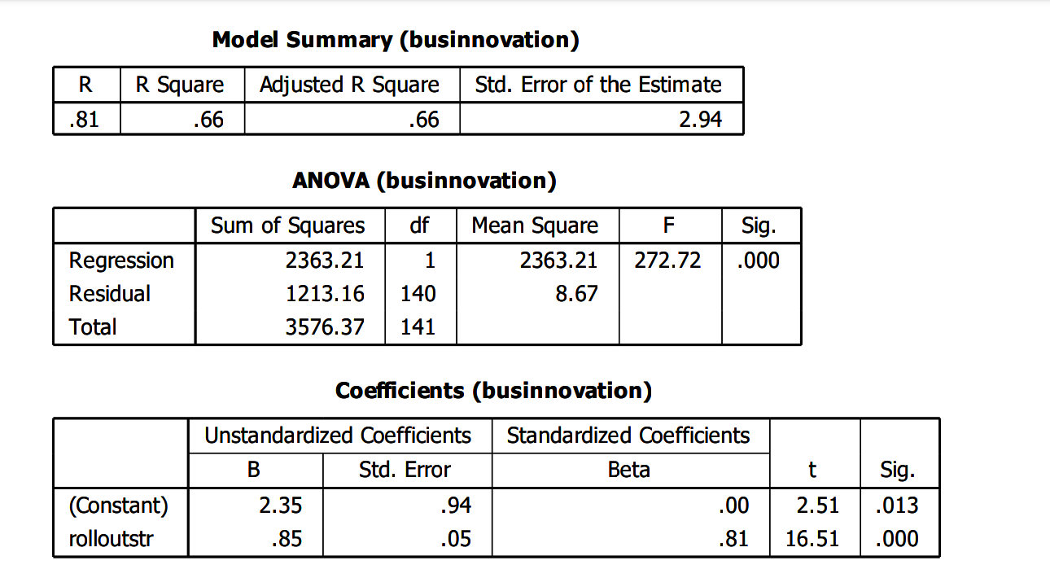
This shows a very strong positive correlation between rollout strategy and business innovation. (R² = 0.66) shows that about 66% of the variation in business innovation is explained by rollout strategy. This is substantial, suggesting rollout strategy is a powerful predictor. Adjusted (R² = 0.66) confirms the model’s explanatory power after adjusting for sample size. The standard error of 2.94 indicates the average deviation of observed values from the regression line is about 2.94 units. The model explains a large proportion of business innovation, meaning rollout strategy is strongly linked to it. The regression model is statistically significant. This means that rollout strategy as a predictor significantly improves the ability to predict business innovation compared to a model with no predictor. The overall model is valid and not due to random chance. The coefficients table constant (B = 2.35, p = 0.013) indicates that when rollout strategy is zero, business innovation has a baseline value of 2.35. The unstandardized coefficient (0.85) means that for every 1-unit increase in rollout strategy, business innovation increases by 0.85 units, holding other factors constant. The standardized beta (0.81) indicates rollout strategy is a very strong predictor of business innovation. The p-value is < 0.001, which is far below the 0.05 threshold, confirming statistical significance. Since the predictor is positive and significant (p < 0.001), we reject the null hypothesis (H₀) and accept the alternative hypothesis (H₁). The regression model is statistically significant (F-test). Rollout strategy explains two-thirds (66%) of the variation in business innovation. The effect is not only statistically significant but also substantively large (Beta = 0.81). The results clearly show that rollout strategy has a strong, positive, and significant influence on business innovation. The null hypothesis is therefore rejected, and the study justifies that rollout strategies are a crucial driver of business innovation.

    - Hypothesis Two
H_{o}: The implementation of 5G has no significant impact on the growth of products, services, and processes within Nigerian businesses.
H_{i}: The implementation of 5G has significant impact on the growth of products, services, and processes within Nigerian businesses.

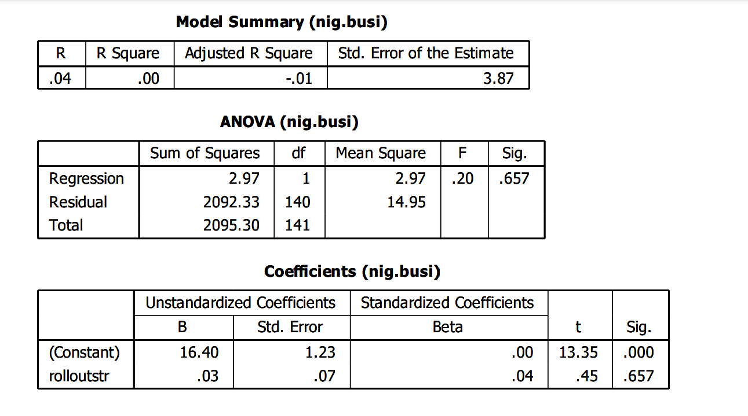
The (R = 0.04) shows weak correlation between 5G rollout strategy and the growth of products, services, and processes within Nigerian businesses. (R² = 0.001) indicate that only (0.1%) of the variance in business innovation is explained by 5G rollout. Adjusted (R² = -0.01) indicates that after adjusting for sample size, the model performs worse than a simple mean-based prediction. Std. Error of Estimate (3.87) indicates high variability in the data not explained by the model. The model barely explains any variation in the dependent variable. An R² of 0.001 is extremely low, suggesting that 5G rollout has almost no predictive power on the growth of products, services, or processes within Nigerian businesses in this dataset. The F-statistic (0.20) is very low, indicating the model does not significantly improve prediction over using the mean. The p-value (Sig. = 0.657) is much greater than 0.05, meaning the model is not statistically significant. There's no evidence that 5G rollout has a meaningful impact on business innovation based on this regression. The coefficient for MTN roll out strategy (B = 0.13) suggests a very small positive effect: for every unit increase in 5G rollout, business innovation increases by 0.13 units. However, the t-value (0.45) is low and the p-value (0.657) is not significant, meaning this effect is not statistically reliable. It is thereby concluded that the 5G rollout variable does not significantly impact the growth of products, services, and processes within Nigerian businesses. The relationship is weak and statistically insignificant. Therefore, we accept the null hypothesis “The implementation of 5G has not significantly impacted innovation in products, services, and processes within Nigerian businesses”.

    - Hypothesis Three
H_{o}: The implementation of 5G has no significant impact on the growth of products, services, and processes within Nigerian businesses.
H_{i}: The implementation of 5G has significant impact on the growth of products, services, and processes within Nigerian businesses.

The (R = 0.04) shows weak correlation between 5G rollout strategy and the growth of products, services, and processes within Nigerian businesses. (R² = 0.001) indicate that only (0.1%) of the variance in business innovation is explained by 5G rollout. Adjusted (R² = -0.01) indicates that after adjusting for sample size, the model performs worse than a simple mean-based prediction. Std. Error of Estimate (3.87) indicates high variability in the data not explained by the model. The model barely explains any variation in the dependent variable. An R² of 0.001 is extremely low, suggesting that 5G rollout has almost no predictive power on the growth of products, services, or processes within Nigerian businesses in this dataset. The F-statistic (0.20) is very low, indicating the model does not significantly improve prediction over using the mean. The p-value (Sig. = 0.657) is much greater than 0.05, meaning the model is not statistically significant. There's no evidence that 5G rollout has a meaningful impact on business innovation based on this regression. The coefficient for MTN roll out strategy (B = 0.13) suggests a very small positive effect: for every unit increase in 5G rollout, business innovation increases by 0.13 units. However, the t-value (0.45) is low and the p-value (0.657) is not significant, meaning this effect is not statistically reliable. It is thereby concluded that the 5G rollout variable does not significantly impact the growth of products, services, and processes within Nigerian businesses. The relationship is weak and statistically insignificant. Therefore, we accept the null hypothesis “The implementation of 5G has not significantly impacted innovation in products, services, and processes within Nigerian businesses”.

  - Discussions of Findings
Of the two null hypotheses that were tested, one was rejected as its corresponding p-value was below the significance level of 0.05 while the other hypothesis was accepted. This study clarifies the ambiguity surrounding the impacts of 5G networks in business innovation and in enhancing the growth of products, services, or processes within Nigerian businesses.

Hypothesis One: The implementation of 5G networks does not have a significant impact on business innovation in Nigeria.
The study explores whether the implementation of 5G networks have a significant impact on business innovation in Nigeria or not. The responses from the questionnaire support those findings with majority of participants recognizing that the implementation of 5G networks has a significant impact on business innovation. The strong statistical evidence from this study supports the hypothesis that there is significant relationship between the implementation of 5G networks and business innovation in Nigeria. The result of the findings indicated significant correlation between the variables. The findings indicated the adoption of MTN’s 5G has increased their business efficiency and productivity. It is therefore suggested that government and private investors should offer grants or low-interest loans to help businesses upgrade infrastructure and adopt smart technologies. These findings are consistent with the study by Kim and Lee (2020) who examined the adoption of 5G in smart factories across South Korea and noted observable advancements in manufacturing accuracy, remote monitoring capabilities, and supply chain flexibility. These advancements were seen to directly attribute to 5G’s high bandwidth and ultra-low latency, which facilitated real-time modifications and predictive maintenance activities that helped reduce downtime and boost productivity. It is therefore recommended that both the Government agencies should create policies that support digital tools and train staff to maximize 5G capabilities.

Hypothesis Two: The implementation of 5G has not significantly impacted the growth of products, services, and processes within Nigerian businesses.
The analysis revealed that the implementation of 5G has no significant impact on the growth of products, services, and processes within Nigerian businesses. The findings indicated that 5G has not fully improved the quality of technology-driven products in Nigeria. It is suggested that there is need to strengthen and expand 5G coverage beyond major cities to rural and industrial zones to ensure broader impact. It is also suggested that there is need to develop tailored pilot programs for sectors like healthcare, manufacturing and agriculture. These findings are consistent with the existing empirical study by Oluwajana, et al., (2023) who explored 5G adoption among Nigerian small and medium-sized enterprises (SMEs) and found that firms with previous exposure to cloud computing, IoT, or AI were more likely to contemplate 5G solutions. Nevertheless, a lack of technical know-how, the high expense of 5G-compatible devices, and doubts about return on investment were recognized as significant obstacles to adoption. Also, Ojo and Adebayo (2022) examined the ICT readiness of Nigerian firms and discovered that despite the rising awareness of 5G, actual adoption remains limited due to cost, skill shortages, and regulatory ambiguities. Their research highlighted that the majority of innovation initiatives are still concentrated in urban centers with relatively superior infrastructure, like Lagos and Abuja. It is therefore recommended that Telecom Providers should improve network reliability and offer affordable business plans for SMEs.

Hypothesis Three: The implementation of 5G has not significantly impacted the growth of products, services, and processes within Nigerian businesses.
The analysis revealed that the implementation of 5G has no significant impact on the growth of products, services, and processes within Nigerian businesses. The findings indicated that 5G has not fully improved the quality of technology-driven products in Nigeria. It is suggested that there is need to strengthen and expand 5G coverage beyond major cities to rural and industrial zones to ensure broader impact. It is also suggested that there is need to develop tailored pilot programs for sectors like healthcare, manufacturing and agriculture. These findings are consistent with the existing empirical study by Oluwajana, et al., (2023) who explored 5G adoption among Nigerian small and medium-sized enterprises (SMEs) and found that firms with previous exposure to cloud computing, IoT, or AI were more likely to contemplate 5G solutions. Nevertheless, a lack of technical know-how, the high expense of 5G-compatible devices, and doubts about return on investment were recognized as significant obstacles to adoption. Also, Ojo and Adebayo (2022) examined the ICT readiness of Nigerian firms and discovered that despite the rising awareness of 5G, actual adoption remains limited due to cost, skill shortages, and regulatory ambiguities. Their research highlighted that the majority of innovation initiatives are still concentrated in urban centers with relatively superior infrastructure, like Lagos and Abuja. It is therefore recommended that Telecom Providers should improve network reliability and offer affordable business plans for SMEs.

CHAPTER 5
SUMMARY OF FINDINGS, CONCLUSIONS, AND RECOMMENDATIONS

  - Preamble
This chapter discusses the findings of the study. The summary of the findings from the data analysed is indicated, as well as, conclusion, contribution to knowledge, limitations, and recommendations, while suggestions for future research were also made.

  - Summary of findings
The result of the study is summarized thus:
- The findings of the study suggested that rollout strategy has a significant effect on business innovation. This was indicated in hypothesis one, (R = 0.81) which shows a very strong positive correlation between rollout strategy and business innovation. Also, (R² = 0.66) shows that about 66% of the variation in business innovation could be attributed to 5G rollout. Also, the F-statistic (272.72) and significance value (p = 0.000) confirmed the model’s overall statistical significance.
- The findings of the study also revealed a contrasting result in hypothesis two “5G rollout variable does not significantly impact the growth of products, services, and processes within Nigerian businesses”. It was revealed that the relationship is weak and statistically insignificant indicating that the implementation of 5G has not significantly impacted innovation in products, services, and processes within Nigerian businesses. As revealed in hypothesis two, (R = 0.04) shows weak correlation between 5G rollout strategy and the growth of products, services, and processes within Nigerian businesses. (R² = 0.001) indicates that only 0.1% of the variance in the growth of products, services, and processes within Nigerian businesses is explained by 5G rollout.

  - Conclusion
This study critically examined the impact of 5G technology rollout on business innovation, service delivery, and operational performance in Nigeria. The findings revealed that while 5G holds substantial potential to transform the Nigerian business landscape, its impact is currently more pronounced in the area of innovation than in overall business performance. Through statistical analyses, it was established that the structure of 5G deployment significantly enhances innovation by enabling faster product development, improving communication, and increases the competitiveness of business in both local and global markets. However, its direct influence on business performance remains limited, suggesting that broader infrastructural, regulatory, and adoption-related challenges may be hindering its full impact. The study also highlighted that most businesses perceive 5G as a tool for future growth, but concerns such as high deployment costs, limited accessibility, and technological readiness continue to pose barriers. 5G technology offers promising prospects for Nigerian businesses, particularly in fostering innovation. To maximize its benefits, there is a need for strategic investment, stakeholder collaboration, policies that support widespread access, digital inclusion and capacity building across sectors.

  - Recommendations
Based on the findings of this study, the following recommendations are proposed to strengthen the implementation of 5G networks on business innovation and growth of products, services, and processes within Nigerian businesses.
- MTN should initiate grant programs for 5G-powered business innovations to stimulate local development.
- There is need to also gather feedbacks from businesses to improve the quality and relevance of 5G services offered.
- MTN should support rural businesses through digital literacy and affordable 5G access to foster inclusive innovation.
- MTN should ensure to expand 5G infrastructure to underserved areas to ensure more businesses can benefit from it.
- 5G services packages should be tailored for sectors like fintech, health, education, and logistics to enhance productivity and innovation.
- Flexible pricing plans should be introduced for small and medium enterprises to promote wider adoption of 5G services.
  - Contributions to Knowledge
This study contributes to the growing body of literature on digital marketing and consumer behavior in several key ways:
- The research helps to highlight how 5G adoption influences efficiency, customer engagement and competitiveness among businesses, especially SMEs.
- The research fills a gap in understanding the real-world applications and limitations of 5G in Nigeria, offering insights into the challenges faced in technology-driven growth such as infrastructure constraints and digital tool adoption.
- The findings also advance the discourse on digital transformation by illustrating the role of 5G in stimulating business innovation, thus providing a foundation for future policies aimed at enhancing technological integration in Nigeria’s economic development.
- The study’s quantitative approach offers a basis for further research on the relationship between emerging technologies and business performance.

  - Limitations of the study
While this study provides valuable insights into the impact of 5G on business innovation and growth of products, services, or processes within Nigerian businesses, certain limitations should be acknowledged:
- The study was conducted with a limited sample size that may not fully represent the diverse business landscape across Nigeria. The findings may therefore have limited generalizability to all sectors or regions within the country.
- The reliance on self-reported survey responses introduces the possibility of response bias, including social desirability bias, which could affect the accuracy of the data related to the perceived benefits of 5G.
- The study primarily examines the direct impact of 5G on business operations, product development, and innovation but does not explore other external factors such as economic policies, regulatory environment, and market competition which may also influence these outcomes.
- The relatively low significance in some statistical tests (hypothesis 2) suggests limited predictive power of some variables, which restricts the ability to draw strong causal conclusions.

  - Suggestions for Further Studies
In light of the findings and limitations of this research, the following suggestions are proposed for future studies:
- Further investigations can be made into the barriers to adopting complementary digital tools (AI, IoT, cloud computing) alongside 5G and how these tools jointly impact productivity.
- Further studies may also examine the effectiveness of governmental regulatory policies on 5G rollout and how these policies affect business adoption and innovation outcomes.
- Future investigations can incorporate in-depth interviews or focus group discussions with business owners, telecom providers, and policy makers to gather rich, contextual insights beyond quantitative data.
- Future studies may compare the effects of 5G technology in Nigeria with other developing or developed countries to identify similarities, gaps, and context-specific challenges or successes.
- Future studies can adopt a longitudinal design to assess the long-term impact of 5G on business growth, innovation and digital transformation over time.

